**EXPERIMENT NO –11:**

**IOT BASED SMART HOME USING CISCO PACKET TRACER.**

**AIM:**

**The main aim is to build an smart home based on the iot systems.**

**Materials required:: Cisco tracer software.**

Procedure ::

1.open the cisco tracer .

2.Then ,network devices-wireless devices-homegateway and place it on the site.

3.then ,end devices—home—celing fan -and windows and other home appliences.

4.then set them as bellow

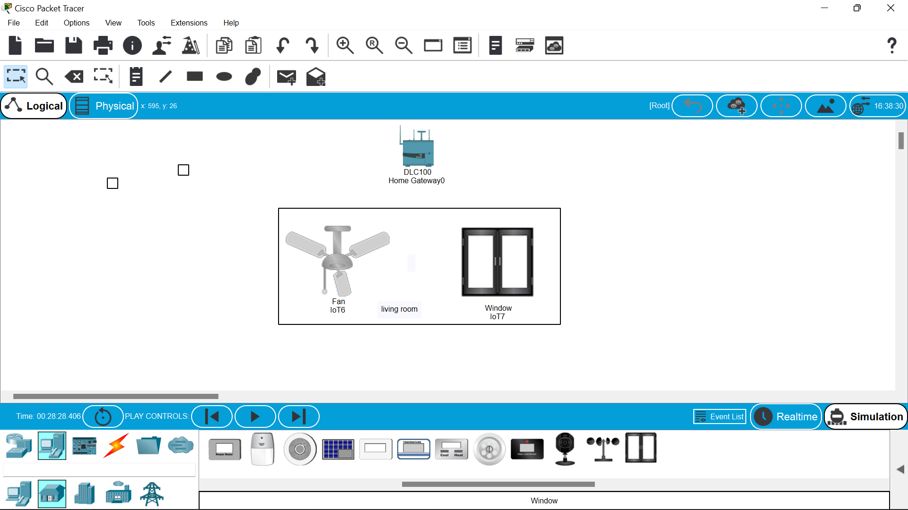

5.then click on the fan -i/o configure –choose the wireless –then configr and wireless0 .repeat the same to the window also.the the dotted lines will be formed btwn the homegatway and fan and window.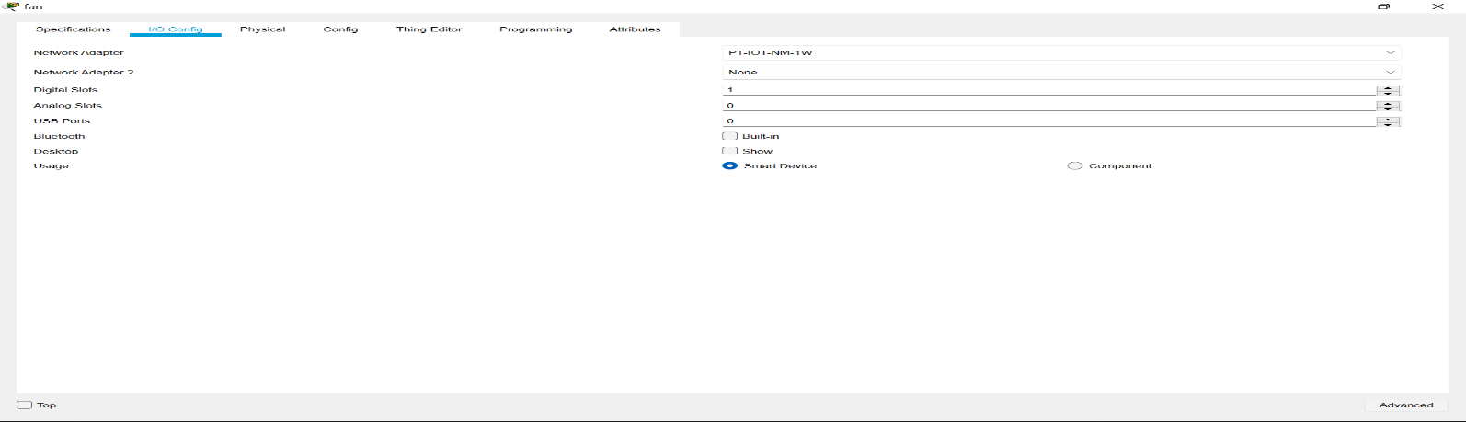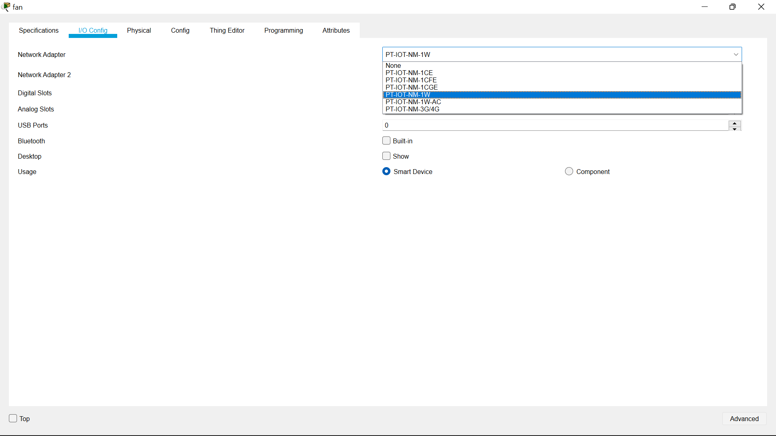

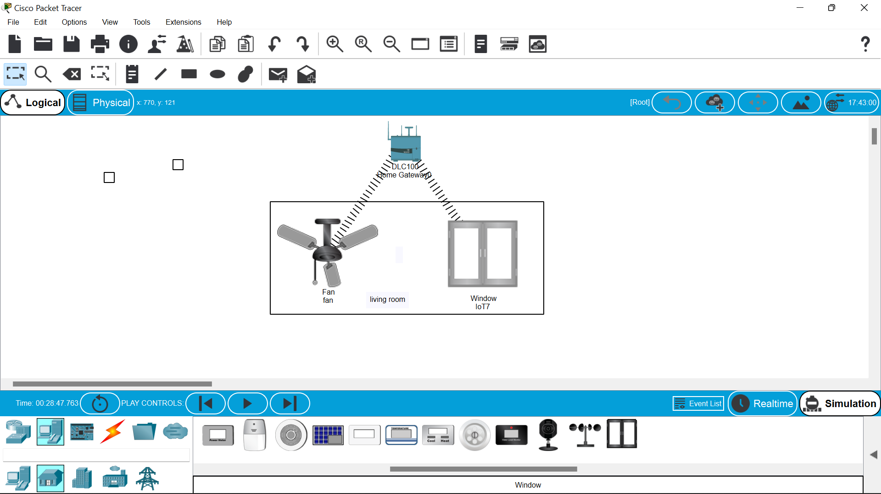

6.Then move to the end devices –click the smartphone to operate the wireless devices.

7.click on the smart phone to configure with homegateway give “HomeGateway” in the ssid space in wireless0.

8.connetion is established.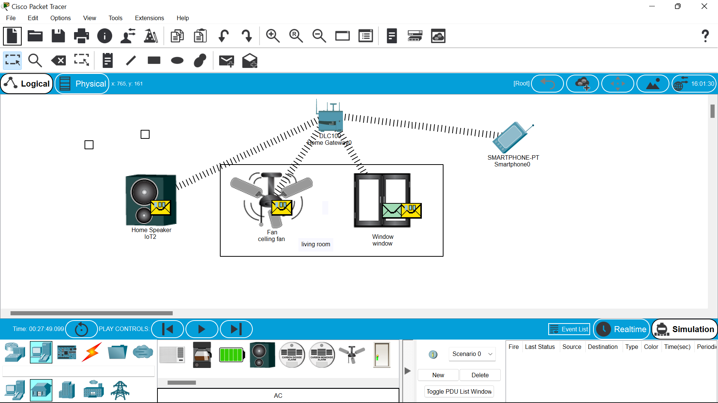

9.then click on the smart phone open desktop –iot monitor—login .10.then you will find switches of celing fan and the window switches .

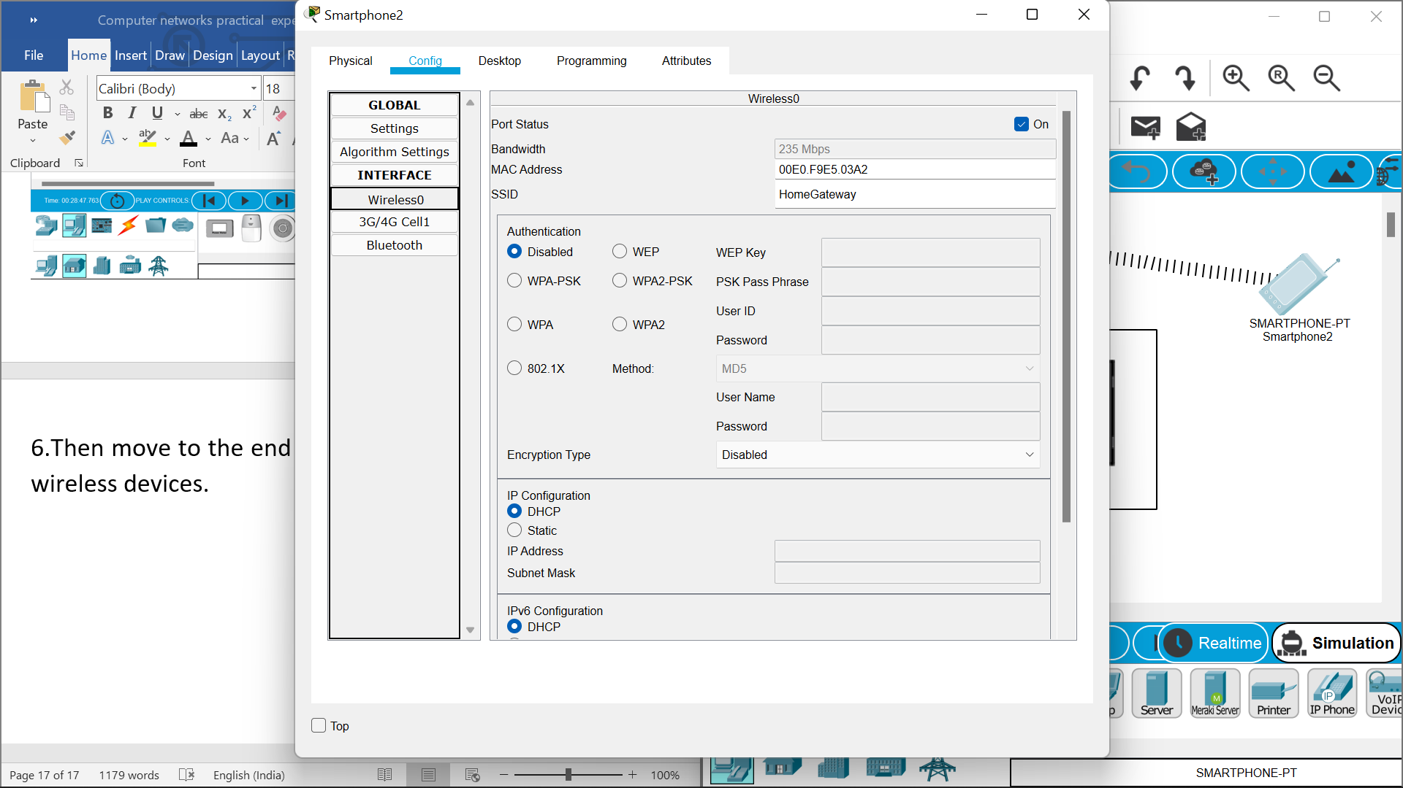

11.below are the switches to access the fan and window.

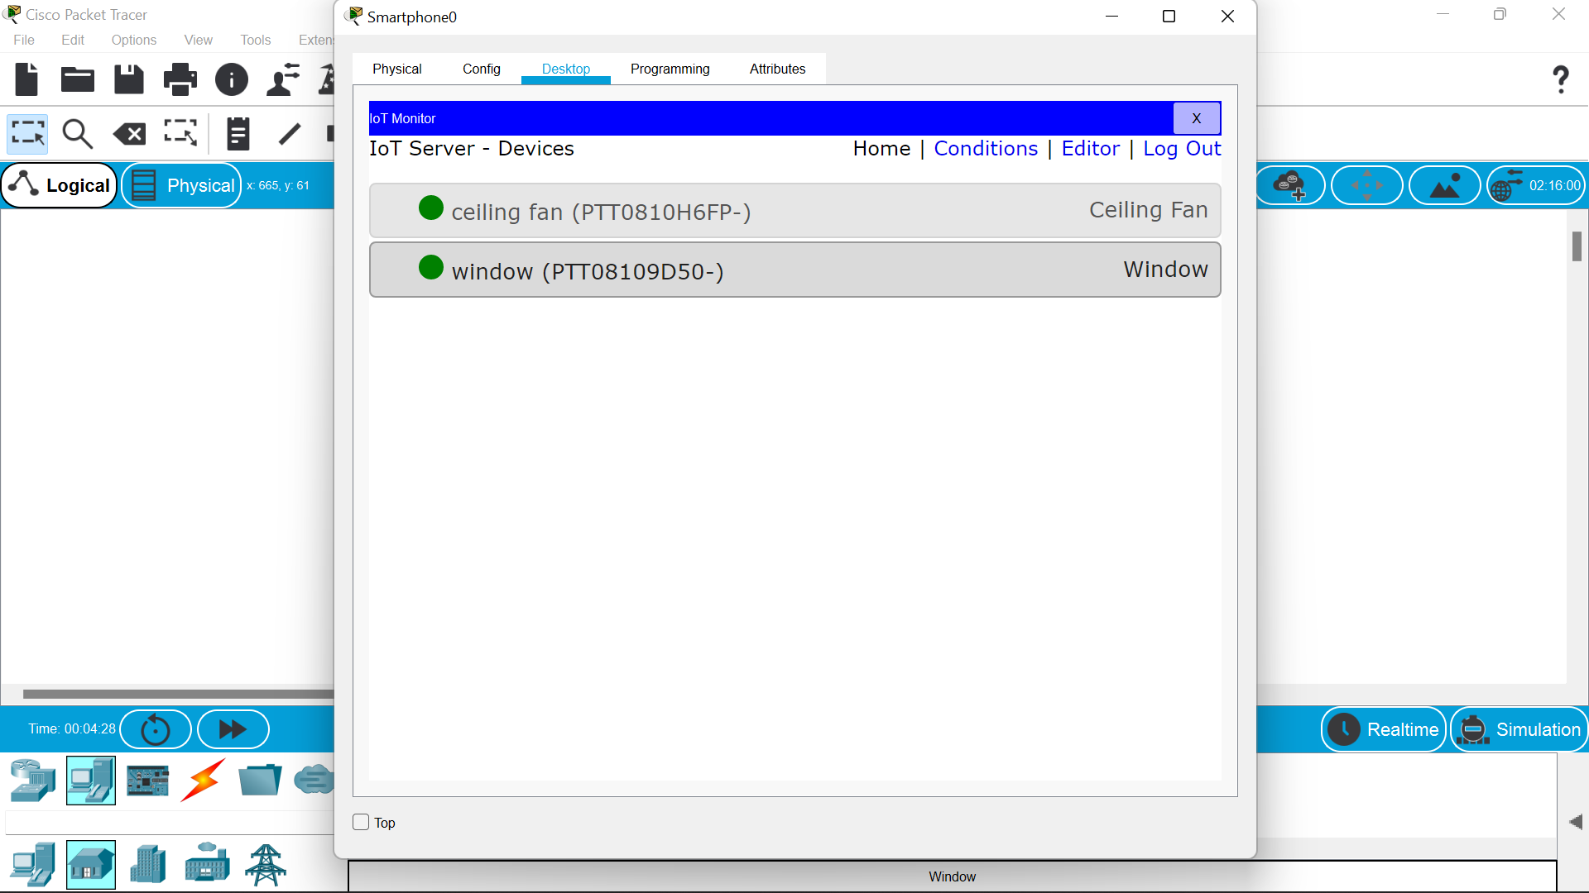.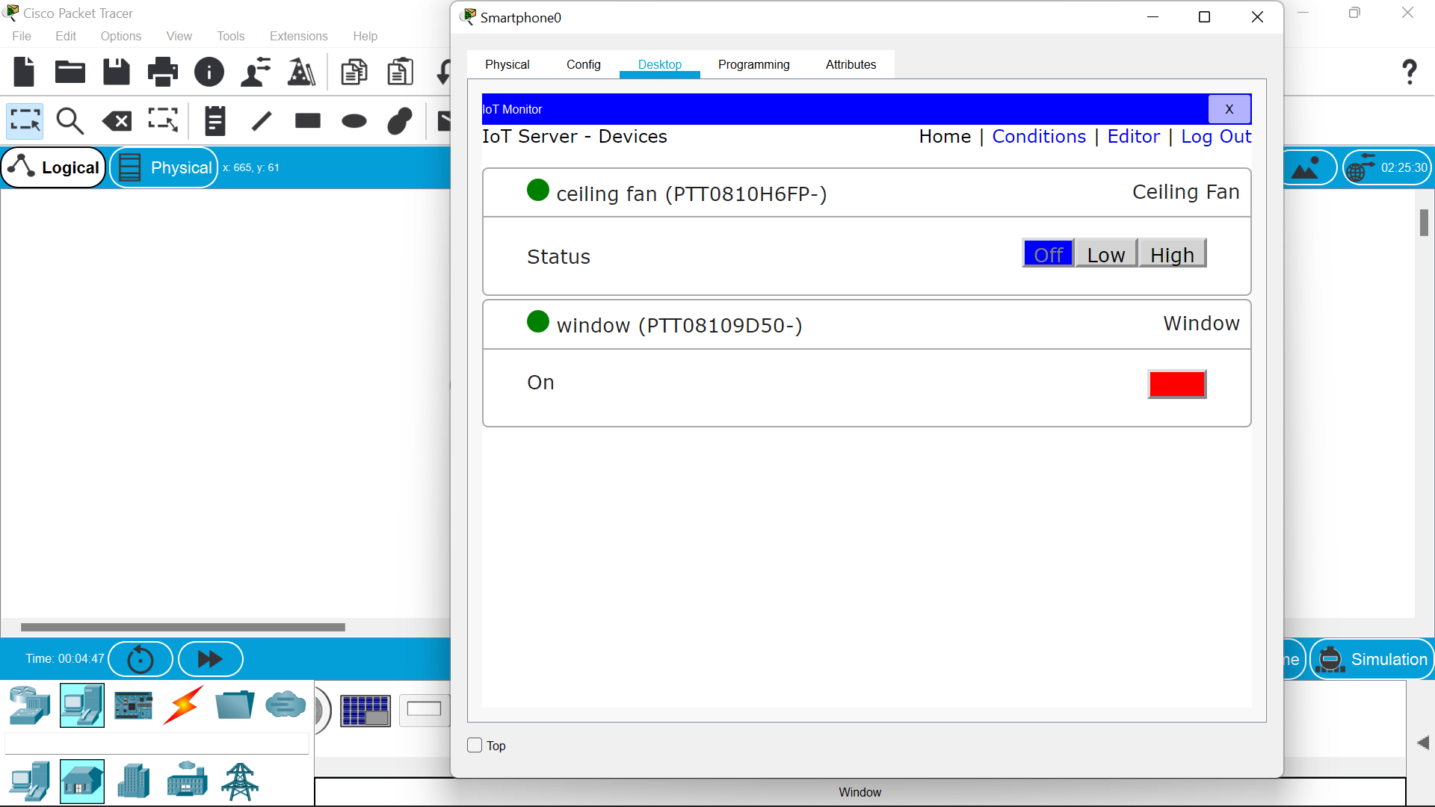

RESULT::

So successfully an iot smart house is made……